Default the value of Dropdown of customer-search page

[ibm-doc](https://www.ibm.com/docs/en/call-center/10.0?topic=code-customizing-shared-components)

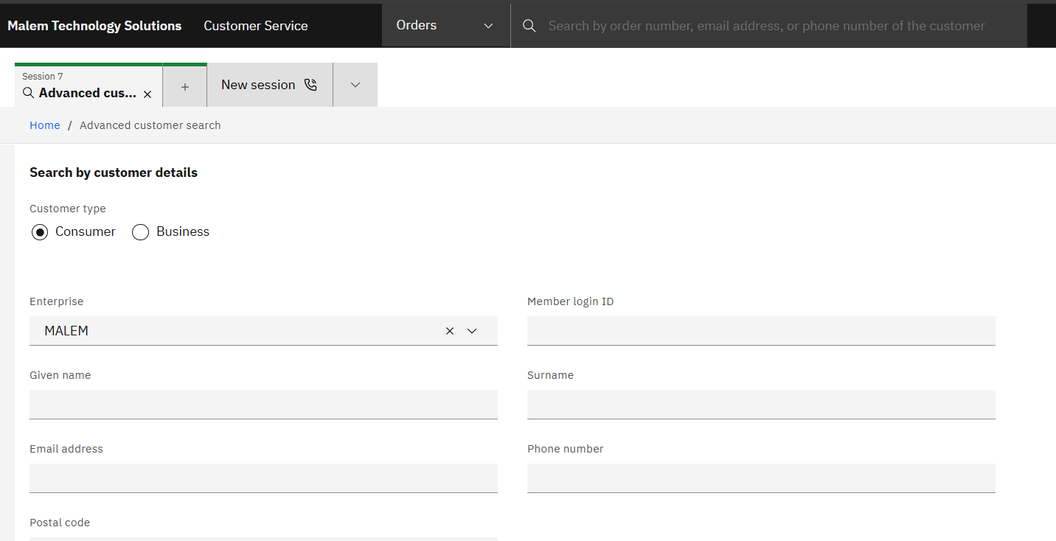

Copy customer-search.class.ts from C:\cc-customCode\call-center-customer\packages\customer-shared\src\lib\search-form to C:\cc-customCode\call-center-customer\packages\customer-search\src-custom

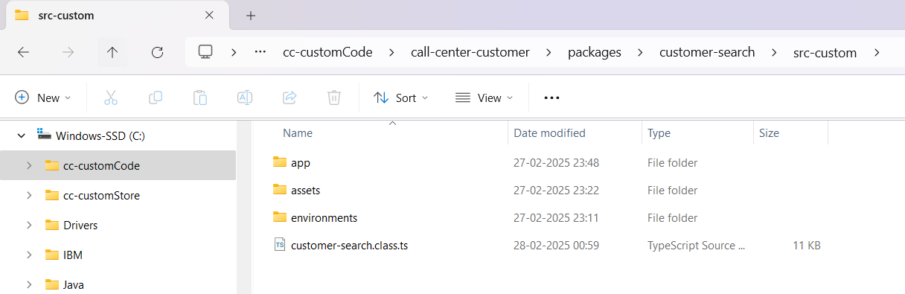

Rename the class to ExtnCustomerSearchForm

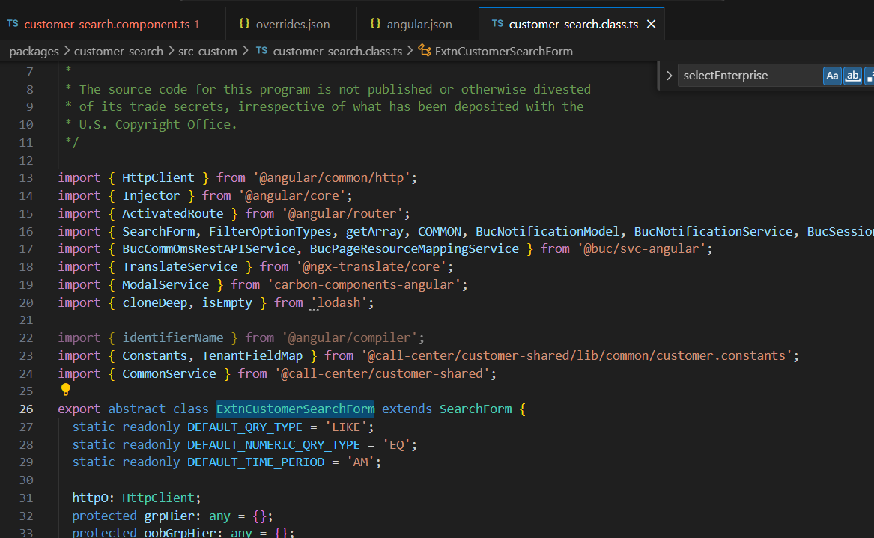

Hardcode the value of selectedEnterprise to MALEM

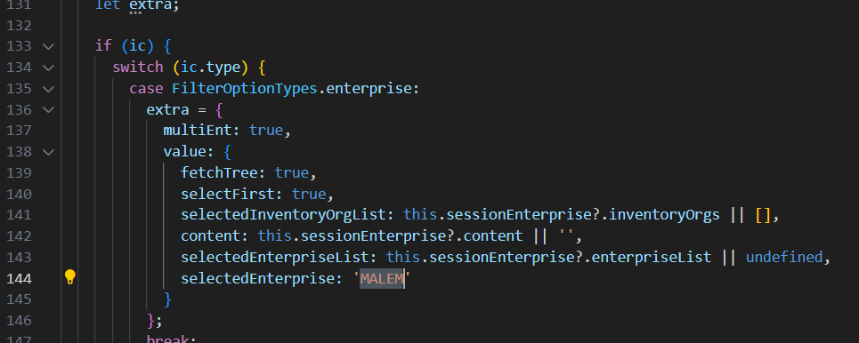

Navigate to C:\cc-customCode\call-center-customer\packages\customer-search\src-custom\app\features\customer and open customer-search.component.ts file

Extend the class ExtnCustomerSearchForm

And import  
 import { ExtnCustomerSearchForm } from 'packages/customer-search/src-custom/customer-search.class';

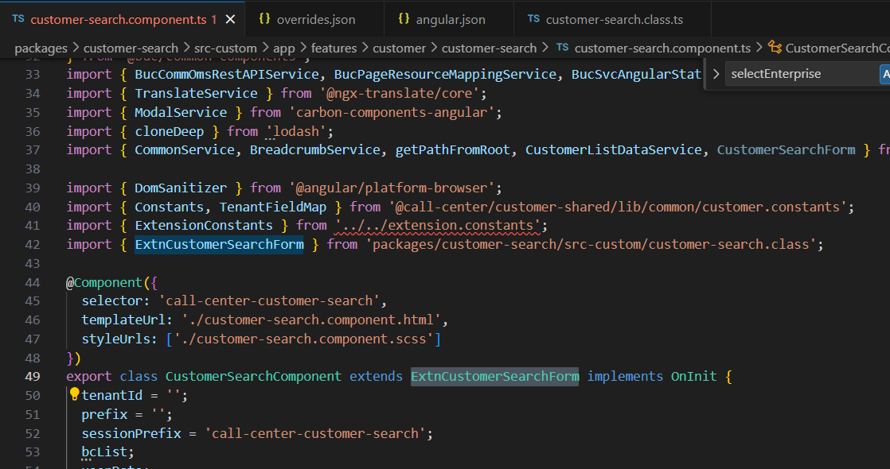

Reload the page and see the default value

